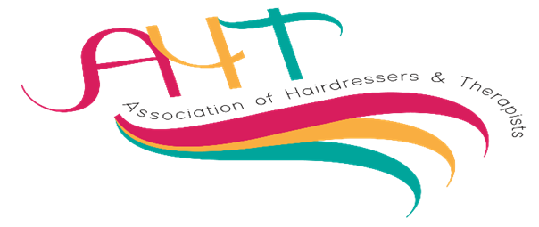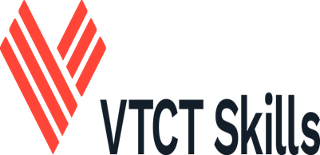

AHT Direct entry Competitions – **Sunday 10th May and Monday 11th May 2026**

**Norcalympia Festival Hall,** Norbreck Castle Hotel, Blackpool.

|  |  |
| --- | --- |
| **Member/s name/s** | **College/training centre** |
|  |  |

**IMPORTANT: -**

**If competitors and or models are registered for multiple competitions, PLEASE allow an extra 15/20 minutes minimum extra time to allow for judging to take place. Competitions will not wait for a competitor or model who is competing in another competition unless there are exceptional circumstances.**

**For the attention of all competitors and models: -**

**Please be aware that all competitors, and models, may be filmed or photographed, as the venue is a public area, and these images may be reproduced for publicity and marketing purposes.**

**Please inform the balloting desk when balloting if the competitor and or model do not wish to be photographed and they will be issued with a card to display on the competition table for scrutineers to monitor.**

**Please tick the box to confirm you have read and agree to the above statement.**

|  |  |  |
| --- | --- | --- |
| **Sunday 10th May 2026** | | |
| **Competition** | | **Name/s of competitors** |
| 1 | 12.00pm  **Fantasy Hair and Make -up total look**. A team event created on a live model  Team will consist of two competitors (and will be given the opportunity to work together at the same time or share the time between each other on the competition floor)  90 minutes |  |
| 2 | 12.00pm  **Creative barbering freestyle pattern designs on a live model**  45 minutes. |  |
| 3 | 12.00pm  **Advanced Nail Art Mirror Image Effect on a live model must incorporate 3D/4D design.**  **Theme: SPRING BLOSSOM**  90 Minutes |  |
| 4 | 12.00pm  **Upper Torso Body Painting on a live model.**  **Theme: BUTTERFLY WINGS.**  120 minutes |  |
| 5 | 12.00pm  **Multiple Piece Prosthetics** on a live model Theme: **DISNEY CHARACTER**  3 hours |  |
| 6 | 12.00pm (set up 11.30)  **Skills Body massage** on a live model  45 minutes  **20 places available** |  |
| 7 | 12.00pm  **Pre-setting dressing long hair** on a professional feminine mannequin or model Theme:**HOLLYWOOD WAVES**  45 minutes. |  |
| 8 | 1.00pm  **Barbering excellence on TYPE 4/3 TEXTURED HAIR on a live model**  45 minutes |  |
| 9 | 1.00pm  **Re-Creation of a fictional tv/film character on a live model**.  60 minutes |  |
| 10 | 1.00pm  **Creative pre colour incorporating vivid and or neon colours blow wave, on a** **professional mannequin.**  30 minutes |  |
| 11 | 2.00pm  **Barbering 3yrs plus vocational experience who are currently registered on a regulatory qualification.**  **Creative masculine cut & style** **on a live model**  45 minutes |  |
| 12 | 2.00pm(set up 1.30)  **Skills: Facial and Day Make-up on a live model** 75 Minutes  **20 places available** |  |
| 13 | 2.00pm  **Asian style Bridal make up**  45 minutes |  |
| 14 | 2.00pm  **Masculine natural make-up suitable for on screen on a live model.** 45 minutes |  |
| 15 | 2.00pm  **Non gel polish: one hand French, one hand red** on a live model  30 minutes |  |
| 16 | 2.00pm  **Ready set Wig**  **Candidates to produce a pre-set wig on a wig block that will be ready for any theatrical stage production. Lace front or hard front can be used.**  45 minutes |  |
| 17 | 3.30pm  **Ageing TV make-up** on a live model to include Face, Neck, and Hands.  60 minutes. |  |
| 18 | 3.30pm  **Masculine long hair fashion cut & finish on a model** can be any gender, **or masculine professional mannequin. Hair must be below shoulder length**  **This competition focuses on masculine long hair – showcasing cutting, layering, texturizing and styling skills.** 45 minutes. |  |
| 19 | 4.00pm  **Catwalk hair, fashion styling on a model or mannequin head. Theme: FASHION FORWARD TRENDS**  45 minutes |  |
| 20 | 4.00pm  **An occasion theme make-up for the mature client 35+ on a live model.**  45 minutes. |  |
| **Monday 11th May 2026** | | |
| 21 | 12.00pm  **CANNOT ENTER ON THE DAY**  **Fantasy Make-Up on a live model.**  Theme: **SEA SERPENTS**  45 Minutes |  |
| 22 | 2.00pm  **Skin fade with beard integration on a live model**.  45 Minutes |  |