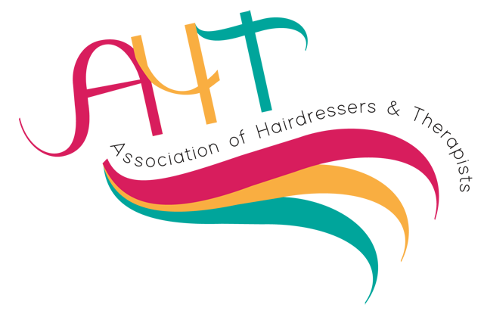
Membership Application 2025-2026

A National Network for Hairdressing & Beauty Professionals

Individual membership: £30.00 per year – allows 3 paid competitors per category per member.

Corporate membership: £200 per year (saving of £100) for 10 memberships (Please complete the form for all 10 members.)
Corporate members can enter unlimited students into competition categories; however competition entries are £15 per student per competition despite individual or corporate membership.

* All competition entries are subject to spaces available in each area. Payment prior to the competition date or receipt of a purchase order is a mandatory requirement.

Please complete the form below and email it with your purchase order or screen print of bank transfer to

jputtahttreasurer@gmail.com

Visit us on social media
https:www.aht-uk.com, https://twitter.com/aht of, https://www.facebook.com/groups/243231353057926

Tick category 囗 £200 Corporate 囗 £30 Individual
Individual/Lead Member Name: | Occupation | ✅ | Occupational Specialism | ✅
College/Centre | Qualified Teacher |  | Hairdresser
Postcode | Professional Trainer |  | Beauty Therapist
Email: | Trained Assessor |  | Nail Technician
Alternative email: | Business Owner |  | Barber
Required Field: I agree that membership, updates, and information will be emailed to me. 囗 | Academy Personnel |  | Make-up Artist
 | Industry Retail Establishment |  | Hair Extension Specialist
 | Retired |  | Wig Maker
 | In Training /Student |  | Aesthetics
 | Manufacturer |  | Other-Please state

For more information contact: National Treasurer: Jonathan Putt: jputtahttreasurer@gmail.com

Corporate Membership

Additional 9 Members

Name | Email | Alternative Email | Occupation | Occupational Specialism | Required: I agree that membership, updates, and information will be emailed to me

