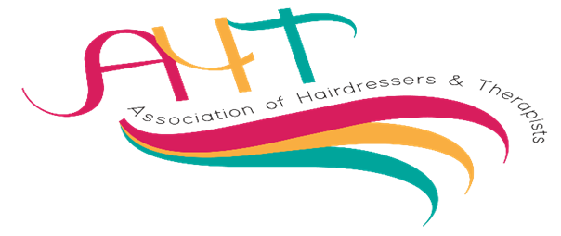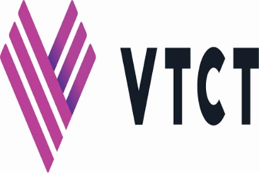
AHT Direct entry Competitions – Sunday 12th May and Monday 13th May 2024
Norcalympia Festival Hall, Norbreck Castle Hotel, Blackpool.
Member/s name/s | College/training centre
For the attention of all competitors and models: -

Please be aware that all competitors, and models, may be filmed or photographed, as the venue is a public area, and these images may be reproduced for publicity and marketing purposes.

Please inform the balloting desk when balloting if the competitor and or model do not wish to be photographed and they will be issued with a card to display on the competition table for scrutineers to monitor.

Please tick the box to confirm you have read and agree to the above statement.

Sunday 12th May 2024
Competition |  | Name/s of competitors
1 | 11.00am  Fantasy Hair and Make -up total look. A team event created on a live model*  Team will consist of two competitors (1hair and 1make-up) Live Model (any gender) Time allowed: 40 minutes for hair and 40 mins for make-up 10 minutes to work as a team | Name x 2
2 | 11.00am  Barbering Free Style Masculine Creative Designs cut and finish on a live model* 45 minutes. | Name/s
3 | 11.00am  Full Body Painting on a live model* Theme: SEASONS 3.5 Hours | Name/s
4 | 11.00am  Full Body Painting for HIGHER LEVEL competitors on a live model*  Theme: THE WORK OF VIVIENNE WESTWOOD. 3.5 Hours | Name/s
5 | 11.00am  Multiple Piece Prosthetics on a live model* Theme: DEMONS 3 hours | Name/s
6 | 11.00am  Skills Body massage on a live model*  45 minutes  Limited number of entries
7 | 11.00am  Pre-setting dressing long hair on a professional feminine mannequin or model*. 45 minutes. | Name/s
8 | 12.00pm  Advanced Nail Art Mirror Image Effect on a live model* must incorporate 3D/4D design.  Theme: BUTTERFLIES. 90 Minutes | Name/s
9 | 12.00pm  Character TV Film Make-Up on a live model* 60 minutes | Name/s
10 | 12.00pm  Vivid styling: Creative pre colour incorporating vivid/ neon colours, on a live model*or  professional mannequin. 30 minutes | Name/s
11 | 1.00pm  Hairdressing skills – Feminine high fashion long hair down on a mannequin of model*  45 minutes | Name/s
12 | 1.00pm  Skills: Facial and Day Make-up on a live model* 75 Minutes  Limited number of entries | Name/s
13 | 2.30pm  Masculine Finish on a professional mannequin.  20 Minutes | Name/s
14 | 2.30pm  Avant Garde feminine finish on a pre -cut & coloured professional mannequin.  45 Minutes | Name/s
15 | 2.30pm  Ageing make-up on a live model any gender, to include Face, Neck, and Hands. 60 minutes. | Name/s
16 | 2.30pm  Masculine long hair fashion finish on a model or masculine mannequin  45 minutes.
17 | 3.00pm  Catwalk hair, fashion styling on a model or mannequin head  45 minutes | Name/s
Monday 13th May 2024
23 | 12.00pm  Fantasy Make-Up on a live model*  Theme: FREE CHOICE  45 Minutes | Name/s
24 | 2.00pm  Current barbering hair and beard trends on a live model*  45 Minutes | Name/s

