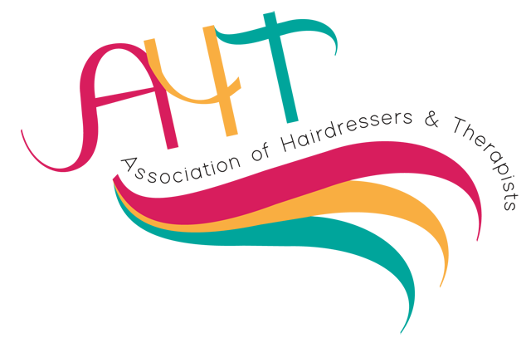

A National Network for Hairdressing & Beauty Professionals

Membership Application 2023-2024

Current membership for 1st October 2023 – 30th September 2024 – costs £30.00 per year

Visit us on social media
https:www.aht-uk.com, https://twitter.com/aht_of, https://www.facebook.com/groups/243231353057926

Complete below and return with payment of £30.00p made payable to AHT or copy of bank transfer to:

Jonathan Putt, National Treasurer, 9 Tamar Close, Whitefield, Manchester, M45 8SJ

Members wishing to pay by bank transfer; please send an order to the above address or by email to jputtahttreasurer@gmail.com

Name: | Occupation | ✅ | Identify Specialism | ✅
Home Address: | Qualified Teacher |  | Hairdresser
Town/City | Professional Trainer |  | Beauty Therapist
County: | Trained Assessor |  | Nail Technician
Postcode: | Business Owner |  | Barber
Telephone: | Academy Personnel |  | Make up Artist
College/Centre | Industry Retail Establishment |  | Hair Extension Specialist
Email: | Retired |  | Wig Maker
Alternative email: | In Training /Student |  | Other-Please state
Required Field: I agree for membership, updates and information to be emailed to me 
I agree to allow AHT to share my details with third parties for relevant marketing material 

For more information contact:
National Treasurer : Jonathan Putt Email: jputtahttreasurer@gmail.com

