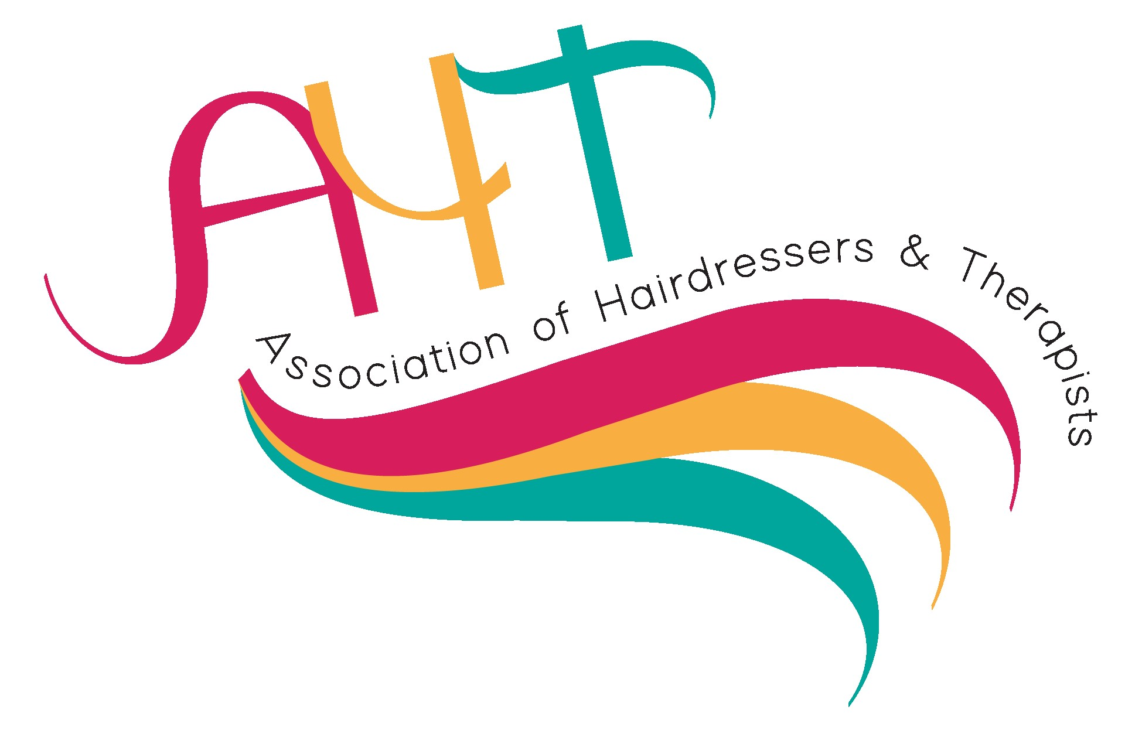
Nomination form for AHT Awards 2024
The awards will be presented at the AHT Learning and Development forum Gala Dinner on Saturday 20th April 2024
Nominated By:  Full name |  | Nominee Details:
Job Title
Centre and address
Email Address
Please tick category you are nominating for (choose only one):
Award Number | Award Title | Sponsor | Category
1 | Contribution to the training and support of apprentices.  This award acknowledges and celebrates a college or training provider’s exceptional contributions to the apprenticeship programmes in the hairdressing, barbering and beauty sector. To include delivery, end point assessment and outcomes. | HABIA
2 | Outstanding Industry and employer engagement.  For this award tell us about partnerships and links that have been developed within the industry and employers. Also, initiatives for staffing CPD opportunities. | PROFESSIONAL BEAUTY
3 | Excellent Support for students and learners.  This award is for an individual that prides themselves on the support that they have given to the students and learners. Describe ways in which they have helped and inspired learners, and how the learners have progressed through the support they have been given. | QUALIFI
4 | Outstanding individual teacher or lecturer of the year.  This award is for teachers or lecturers who have gone beyond their job role in inspiring all students and learners to reach their potential. They always deliver exciting high-quality teaching, inspiring their students or learners to reach their full potential. | CITY & GUILDS
5 | Exceptional team.  The college or training centre or school team will have to demonstrate how the team has impacted on students and learners and their lives; describe the work they have done to enable students and learners to achieve their goals and ambitions. | VTCT

Please return your submission, by Friday 22nd March, with no more than 500 words on a word document electronically to:

Denise Johnson at: DJohnson064@hotmail.com

