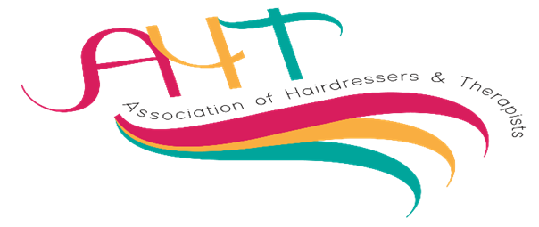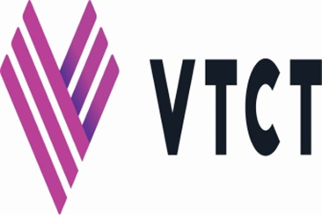
AHT regional entry Competitions
Member/s name/s | Membership number | College/training centre
For the attention of all competitors and models: -

Please be aware that all competitors, and models, may be filmed or photographed, as the venue is a public area, and these images may be reproduced for publicity and marketing purposes.

Please inform the balloting desk when balloting if the competitor and or model do not wish to be photographed and they will be issued with a card to display on the competition table for scrutineers to monitor.

Please tick the box to confirm you have read and agree to the above statement.

Area:
Competition |  | Name/s of competitors
1 | 10.00am  1st year commercial Blow Dry and Finish on a professional feminine above shoulder mannequin head.  45 minutes
2 | 10.00am  Half Body Painting: on a live model* Competitors must have had no more than 2 years’ experience. Theme: SEASONS. 2.5 hours
3 | 10.00  Half Body Painting for HIGHER LEVEL competitors on a live model*  Theme: THE WORK OF VIVIENNE WESTWOOD. 2.5 hours
4 | 10.00am  Authentic (true to the period) 1960’s Make-up on a live model* 45 minutes
5 | 10.00am  Gender Transformation (NOT DRAG or CHARACTER make-up) on a live model* 60 minutes
6 | 10.00am  Creative Nail competition judged on a pre-prepared presentation Mood Board: not on model.  Theme: SPIRITUAL BELIEFS
7 | 11.00am  Barbering, Cut & Finish on a live model* 45 minutes
8 | 11.00am Regional only  Evening Style with Ornamentation on a professional feminine UNIFORMED COLOUR mannequin head.  Competitors must be at school and aged between 14-16 years of age.  30 minutes
9 | 11.00am  Fantasy Hairdressing total look on a live model* 30 minutes
10 | 11.00am  Full Face Painting on a live model*  Theme: NATURE 45 minutes
11 | 11.00am Regional only  Up to entry 3 Inclusive skills long hair fashion style to include a plait and ornamentation, on a professional mannequin head.  45 minutes  Competitors can receive agreed support during the competition that is outlined in their support statement
12 | 11.00am  Commercial Nail Art Gel polish on a live model* Theme: COLOUR INFUSION 60 minutes
13 | 12.00pm  Commercial Feminine Cut and Blow on a professional mannequin head.  45 minutes
14 | 12.00pm  Bridal Feminine hair styling on a live model* or professional female mannequin head. 45 minutes
15 | 12.00pm  Prom themed make-up. Competitors can complete on themselves or on a live model* 45 minutes Competitors must be at school and aged between 14-16 years of age.
16 | 12.00pm  Glamorous Drag Make-Up Style on a live model* 90 minutes
17 | 1.00pm  Feminine Fashion Blow dry on a pre-prepared cut & coloured professional mannequin head. 30 minutes
18 | 1.00pm  Editorial Style Make-up on a live model* Theme: HIGH FASHION MAGAZINE FRONT COVER. 45 minutes
19 | 1.00pm  Barbering creative masculine cut & finish on a pre-coloured live model.  45 minutes
20 | 2.00pm  Feminine Bridal Make-up on a live model* 45 minutes
21 | 2.00pm  Feminine Evening Style can be on a live model* or a professional mannequin head. 45 minutes
22 | 2.00pm  Create an Image Based on a Theme. A team event created on a live model*  Team will consist of two competitors (1hair and 1make-up)  Theme: CARIBBEAN CARNIVAL  90 minutes.

